# LIST RENTAL THROUGH MAILERS HAVEN

# Process Overview

1. In Mail Shop, use the service code ‘LIST’ for List Rental in the DP Dept. In the details of this service code include the parameters for the list rental and the Mailers Haven order number, search # or count #. *More detail on this below.*
2. The ‘LIST’ service code should be the first service code on the work order in the DP dept.
3. Billable price for list rental can be found in the price list but is generally 2x cost.
4. When entering the price for billing, use the full quantity of records rented and the per piece price.
5. Send the client a ‘map’ of the geographic area the rented lists correspond to and get their approval. This will assure that the geo is correct and assures client and Five Maples are on the same page.
6. Print two copies of the Mailers Haven invoice at the time the order is placed. One copy goes into the job bag and the other is forwarded to accounts payble.
7. Use the Mail Shop work order number as the ‘Purchase Order #’ followed by the Mail Shop Customer Code. For example: 64825FRPU. This reference number provides continuity for billing.
8. Download and save the file/files to the work order on L drive.

# Work Order Comments for the List Rental Service Code

Some general guidelines for what information to include under the List Rental service code on the work order are:

1. the Mailers Haven Search # or Count # for consumer lists.

Or the Mailers Haven Order Number for occupant lists.

*More on how to find and search the Mailers Haven web site on this below.*

1. A description of the list parameters. In some cases this can be specific, as shown in the example below, top left and in other cases only general, as the details are too numerous to be pasted into a work order. The Project Manager should use common sense. Even in the case of the description top left, which names specific towns, it doesn’t specify the zip codes that were pulled for those towns.

Mailers Haven retains the list details for consumer list searches however it does not for occupant searches. So, details for occupant list rentals like whether the list is a 1x rental, includes PO Boxes, Residential or Business or both, includes names or no names, etc., can sometimes be helpful when re-renting the following year or for the next mailing.

Here are a few examples:

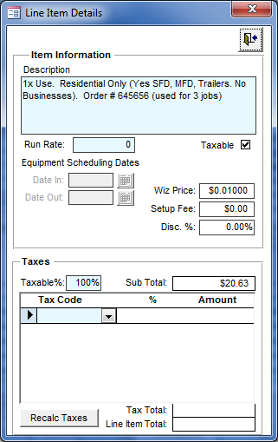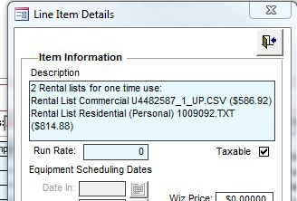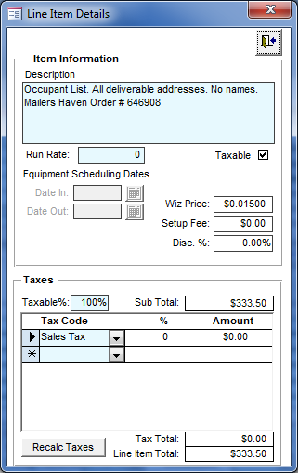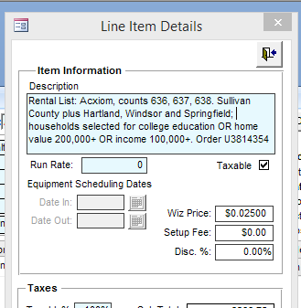

NOTE: example in the top right references the list names, which is not ideal because there is no easy way to relate the file name of a list rented through the Occupant database to the original order number. For lists rented through the Consumer databases of (Axiom & Excelsior) there is a correlation as the list name is the same as the search #.

Placing an order for list rental with Mailers Haven

Mailer’s Haven is not a list compiler. They are a portal for several of the major big data compilers, specifically Acxiom and Info USA, but some others as well. Even though we mark up their price, we still are providing a better price than a small mailer can get by going directly to the big data companies.

Mailers Haven does not deal directly with end users, only with brokers, agencies, mailers and printers who mail.

All list we rent with Mailer’s Haven have a current NCOA, and have been run though the DMA’s (Direct Marketing Association) Do Not Mail registry.

About 8% of the records in a rented list are undeliverable. Mailer’s Haven ‘guarantees’ 92% deliverability.

1. Log into the Mailers Haven web site
2. Occupant lists, usually used for ‘saturation’ mailings specific to a certain geography or zip code/codes, can be rented under the Saturation Lists section.
3. Consumer lists, usually rented when the mail recipient is defined by a set of criteria in addition to geography. For example age, income, hobbies, etc., can be rented under the Consumer Lists section.

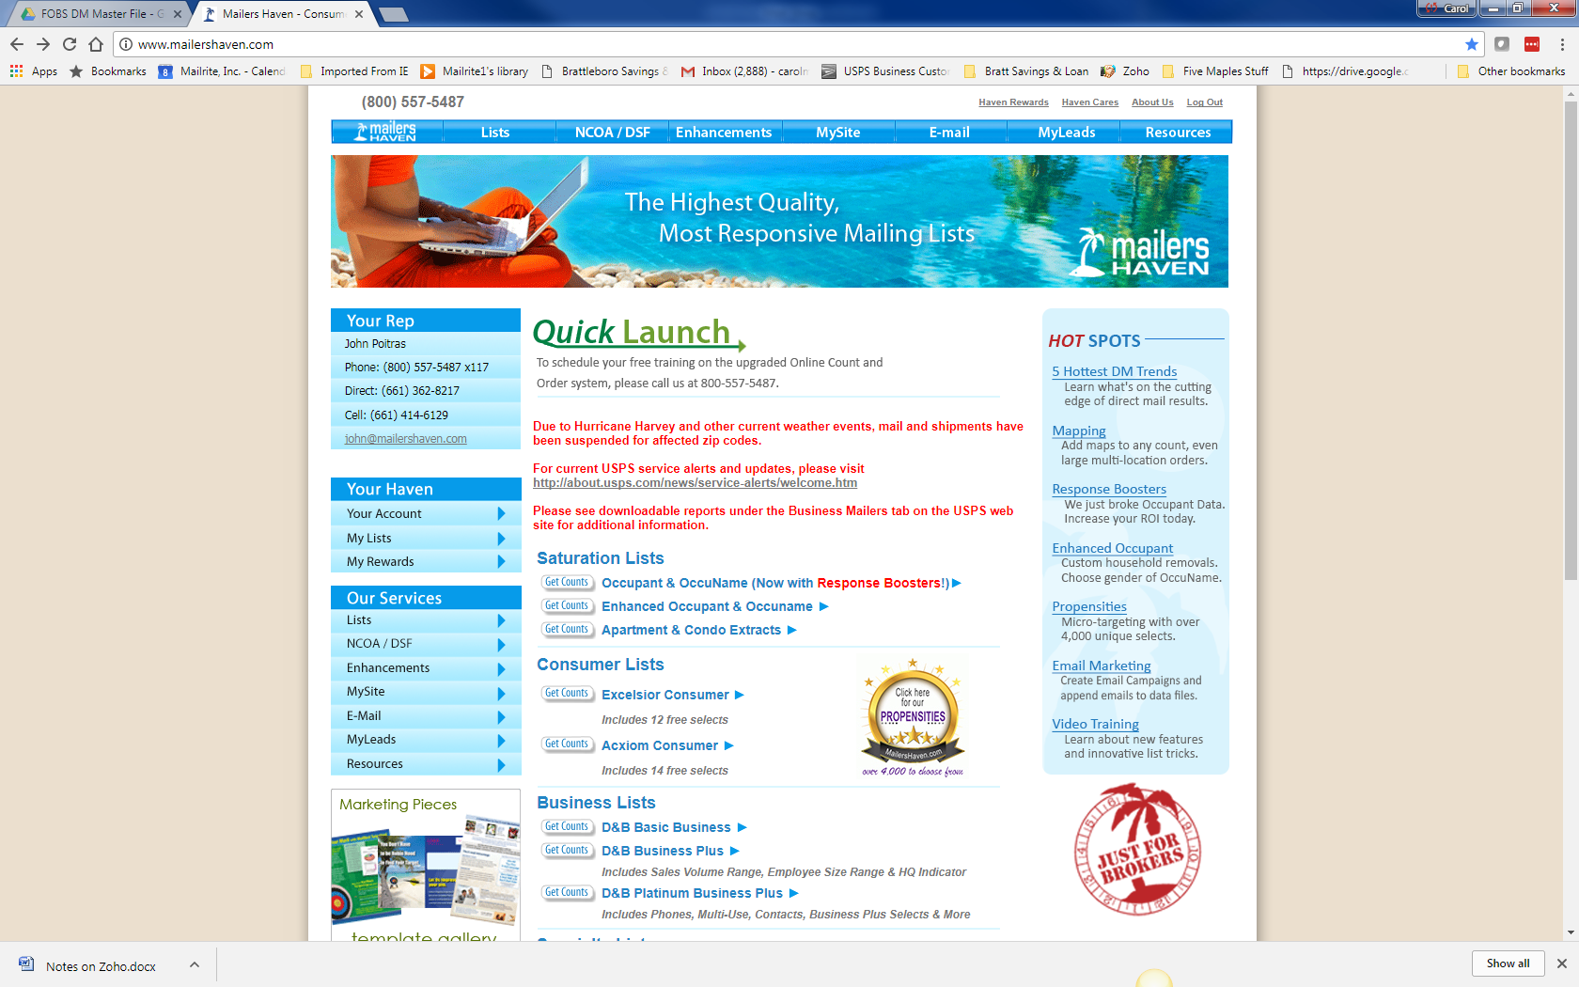

When placing an order for an Acxiom Consumer list, Mailer’s Haven names the search (and the list file) with a number starting with U. *See Acxiom Counts image below.*

When placing an order for an Occupant list, Mailer’s Haven assigns a 6 digit Order Number.

On their web site it is possible to search for a previous order as shown in the following screen shots.

* 1. On the left below is the Axciom (consumer) “Past Orders” screen which shows the U number of the list which also corresponds to the actual file name of the list once it is downloaded. This is useful when re-ordering or trying to match up a list with an order because the file name matches the search #.
  2. On the right is the “View Submitted Orders Screen” for saturation Occupant lists and you can see that the referenced number is not a U number, but instead is the order number. Confusingly, the Order Number is not the file name of the list once the order is placed. So referencing the Order Number on the Work Order in Mail Shop is the best way to record this number.

Acxiom Past Orders Occupant: View Submitted Order

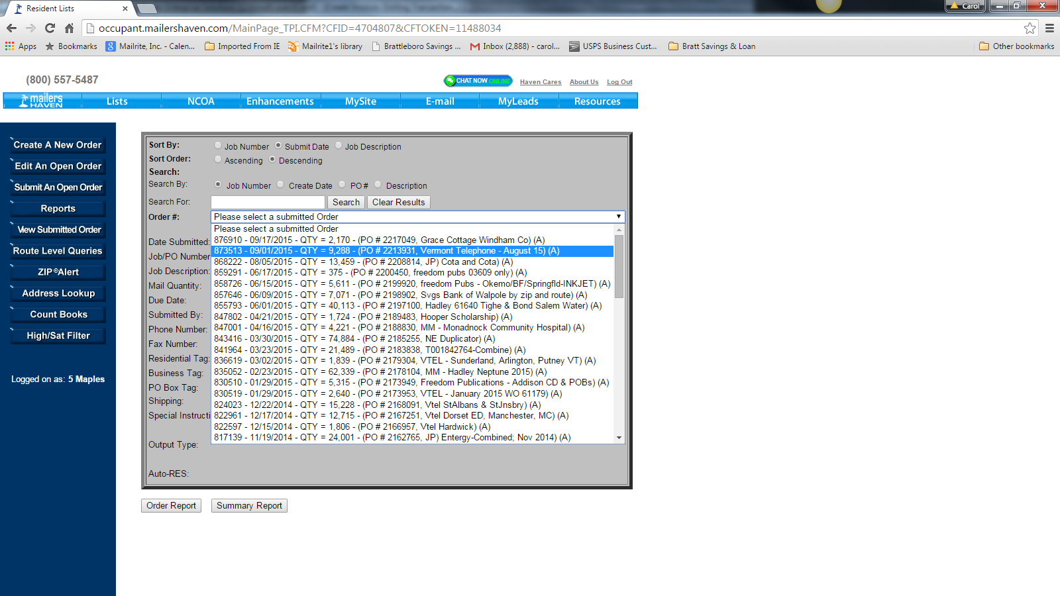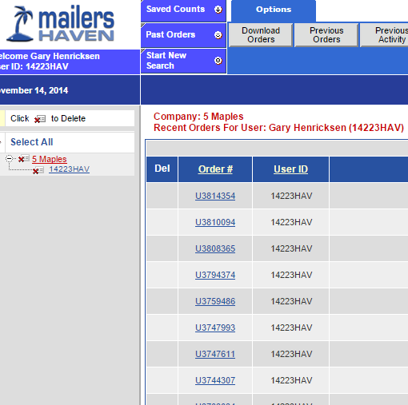

# Finding a list that’s been rented on the Mailers Haven Web Site

It’s very common to enter the details of the list rental and then ‘run’ the list to get a count for the mailing, check geo, etc. This might happen several times before the ‘final’ list rental parameters are known. During this time a Project Manager might create and run several list itterations, all saved on the Mailers Haven site for reference.

Consumer Lists

Choose the My Lists option on the Mailers Haven web site.

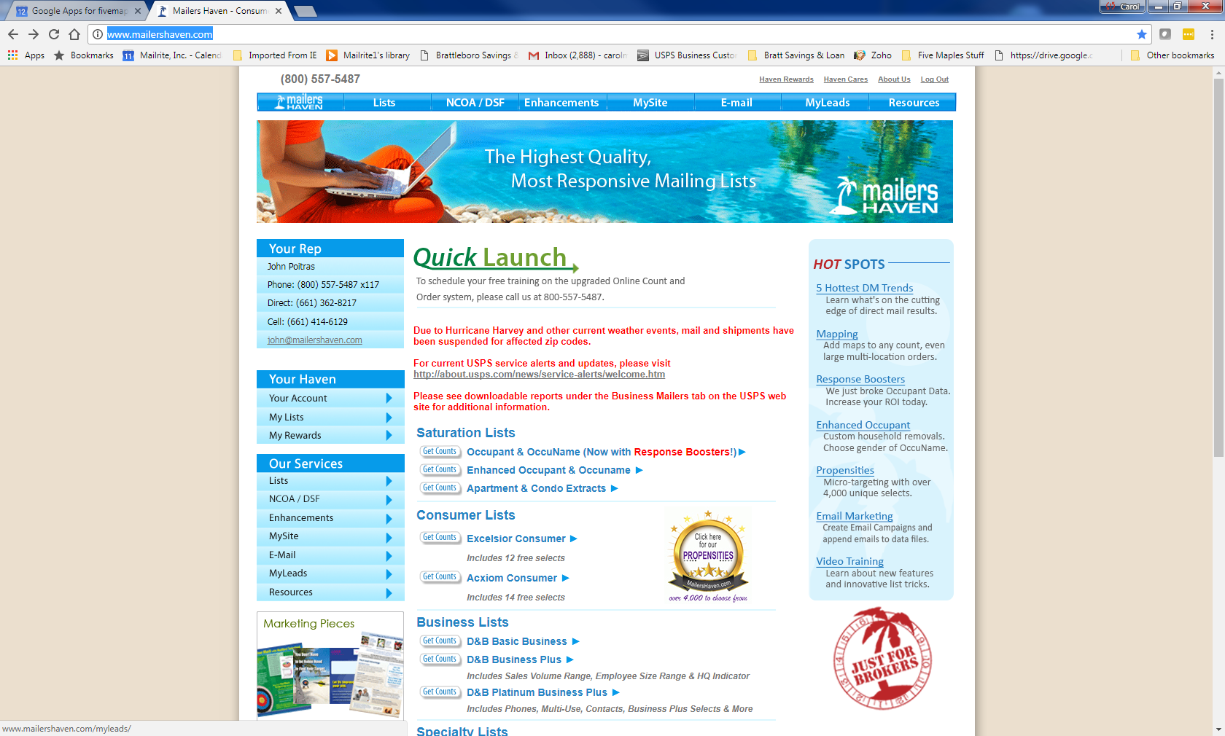

From there, choose ‘Click here to Download Other Lists Not Listed Here’.

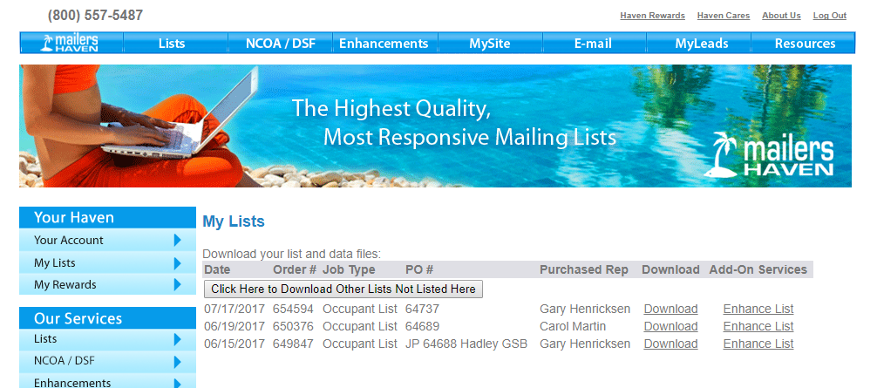

You arrive at a screen that offers three options, Last 5 Searches, Orders Available for Download or Last 5 Orders. You may be able to find the list you’re looking for here, if not, choose the ‘more’ button on the far right of each section.

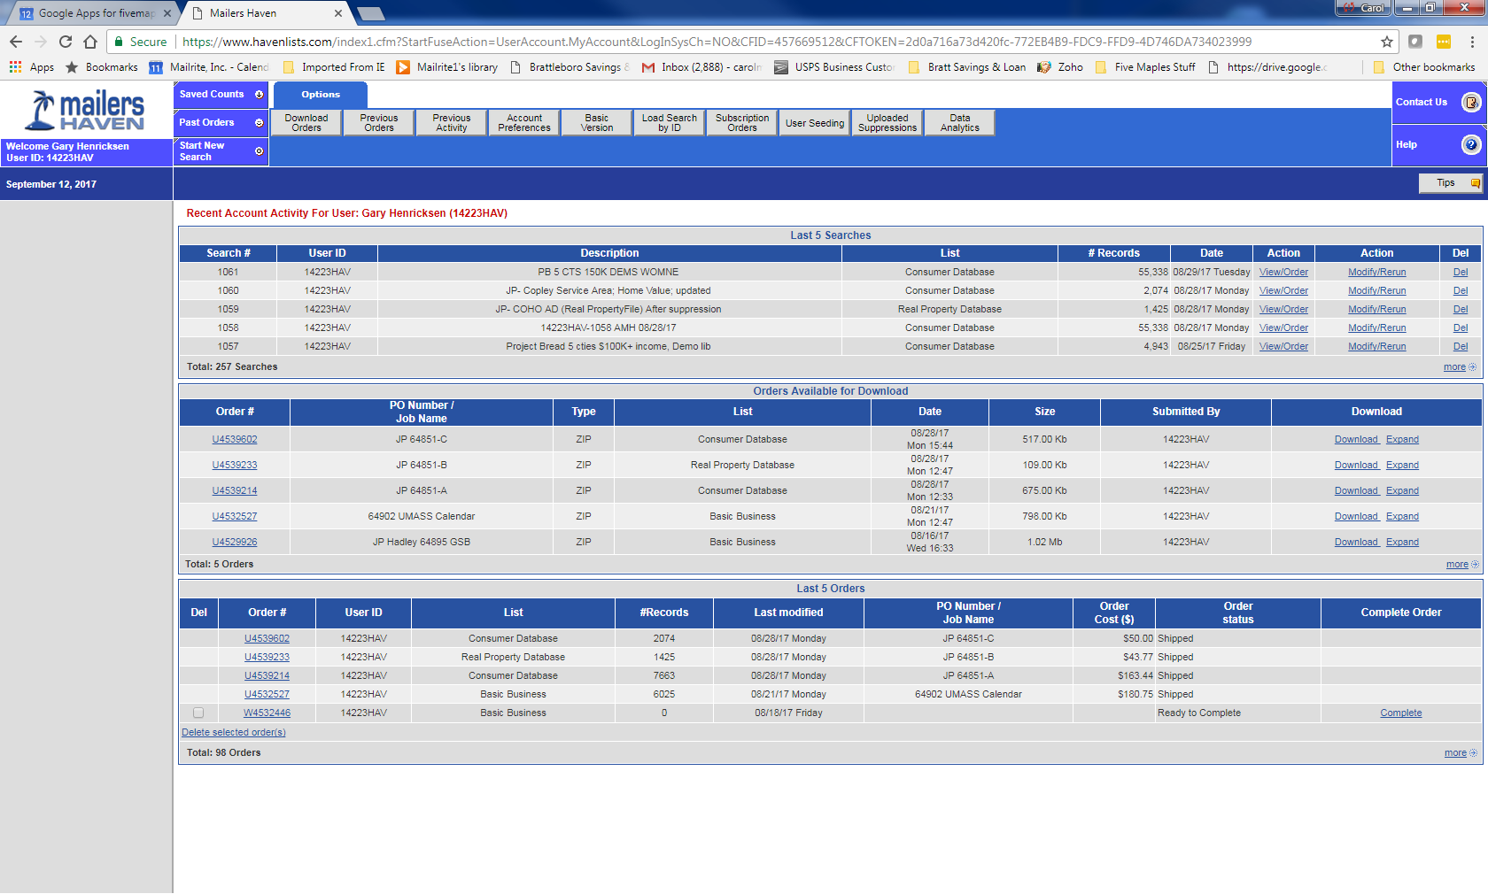

In the Acxiom and Excelsior Consumer databases, when you run a count and send yourself a report, Acxiom assigns a Search # and Excelsior assigns a Count number, as shown in the following screen shots. These numbers can be used to call up that search in the future, for example, to examine the selects that were used or to modify and rerun for a future order.

The Real Property, New Movers, Business as well as most of the other specialty databaes, are Acxiom databases and use Search#.

Acxiom counts Excelsior counts

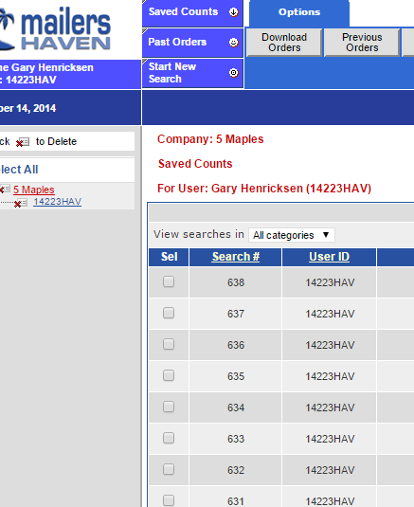

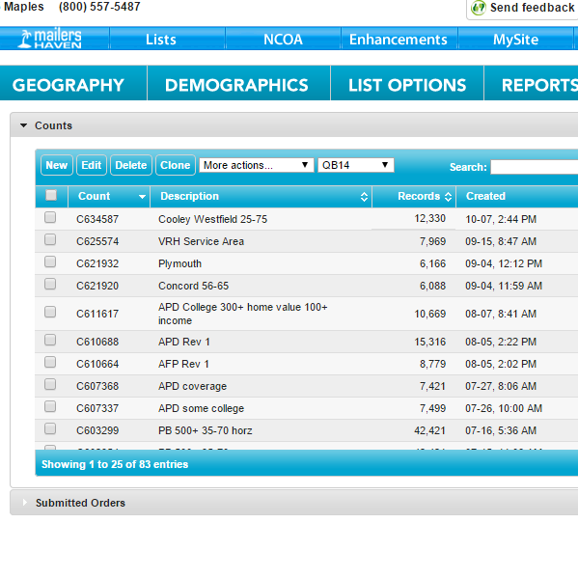

In the Occupant database, when you run a count and send yourself a report Mailers Haven asigns a ‘temporary’ order number, or T number, as shown in the following screen shot. This is equivalent to the Search # in Acxiom and you can call up the list by using this number until you place your order.

Once the order is placed, the temporary number is no longer useful. Instead, use the ‘Order Number’. You can now locate your list by searching ‘View Submitted Order’

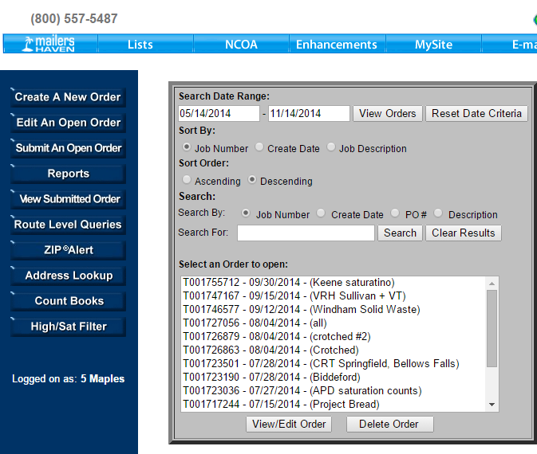

# Purpose of the Work Order Comments

The purpose of the work order comments is to provide enough information to the next person such that they could locate the original ‘search’ or ‘order’.

Thus, for consumer lists, THE ONLY TRUE DESCRIPTION OF THE LIST YOU ORDERED IS THE COUNT REPORT YOU USED TO ORDER THE LIST. The safest way to access that count report, making sure you have the right one, is to access the order screen via, for example from My Lists, as shown below, Click Here4 to Downlad Other Lists Not Listed Here, (as shown)

Then ,referencing the order number or PO (Five Maples Job Number), click on the Order Number

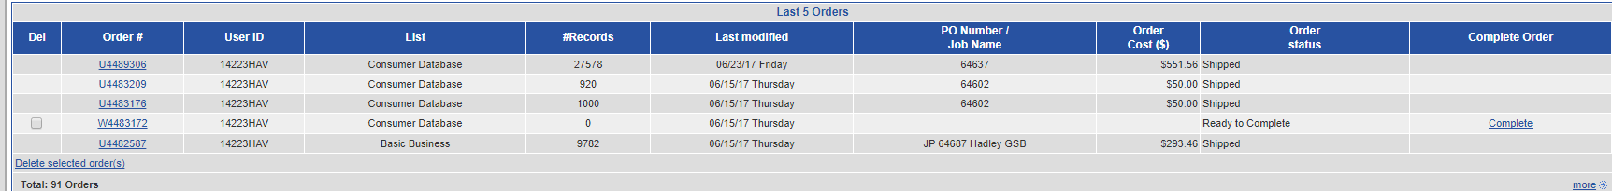

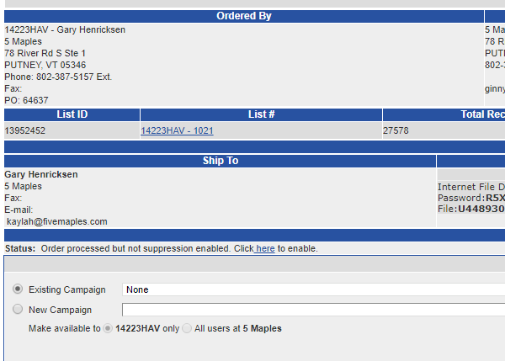And it will take you to the order screen where you can see and click on the Search#, which in the example shown is 1021.

How to navigate the Mailers Haven Web Site